Packet Tracer – Troubleshooting Enterprise Networks 2

1. Topology

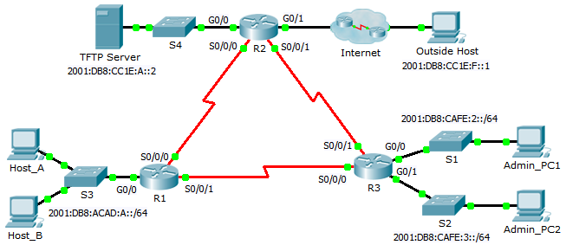

1. Addressing Table

|  |  |  |  |
| --- | --- | --- | --- |
| Device | Interface | IPv6 Address/Prefix | Default Gateway |
| R1 | G0/0 | 2001:DB8:ACAD:A::1/64 | N/A |
| S0/0/0 | 2001:DB8:ACAD:12::1/64 | N/A |
| S0/0/1 | 2001:DB8:ACAD:31::1/64 | N/A |
| R2 | G0/0 | 2001:DB8:CC1E:A::1/64 | N/A |
| G0/1 | 2001:DB8:ACAD:F::2/64 | N/A |
| S0/0/0 | 2001:DB8:ACAD:12::2/64 | N/A |
| S0/0/1 | 2001:DB8:ACAD:23::2/64 | N/A |
| R3 | G0/0 | 2001:DB8:CAFE:2::1/64 | N/A |
| G0/1 | 2001:DB8:CAFE:3::1/64 | N/A |
| S0/0/0 | 2001:DB8:ACAD:31::2/64 | N/A |
| S0/0/1 | 2001:DB8:ACAD:23::1/64 | N/A |
| Admin_PC1 | NIC | 2001:DB8:CAFE:2::2/64 | FE80::3 |
| Admin_PC2 | NIC | 2001:DB8:CAFE:3::2/64 | FE80::3 |
| Host_A | NIC | DHCP Assigned | DHCP Assigned |
| Host_B | NIC | DHCP Assigned | DHCP Assigned |
| TFTP Server | NIC | 2001:DB8:CC1E:A::2/64 | FE80::2 |
| Outside Host | NIC | 2001:DB8:CC1E:F::1/64 | FE80::4 |

1. Background

This activity uses IPv6 configurations that include DHCPv6, EIGRPv6, and IPv6 default routing. Your task is to review the requirements, isolate and resolve any issues, and then document the steps you took to verify the requirements.

1. Requirements

**DHCPv6**

* **Host_A** and **Host_B** are assigned through IPv6 DHCP configured on R1.

**IPv6 Routing**

* Each router is configured with IPv6 EIGRP and uses AS 100.
* **R3** is advertising a summary route to **R2** and **R1** for the two **R3** LANs.
* **R2** is configured with a fully specified default route pointing to the **ISP**.

**Connectivity**

* Devices should be configured according to the Addressing Table.
* Every device should be able to ping every other device.

1. Troubleshooting Documentation

|  |  |  |
| --- | --- | --- |
| **Device** | **Error** | **Correction** |
|  |  |  |
|  |  |  |
|  |  |  |
|  |  |  |
|  |  |  |
|  |  |  |
|  |  |  |
|  |  |  |
|  |  |  |
|  |  |  |

1. Verification Documentation

Capture output from verification commands and provide documentation proving that each of the requirements has been satisfied.

**Note**: Some EIGRPv6 commands are not scored in Packet Tracer v6.0.1. Your instructor will verify that all requirements are met.

1. Suggested Scoring Rubric

Packet Tracer scores 50 points. The troubleshooting documentation and instructor verification is worth 50 points.